Research Synthesis Matrix Instructions
Use this Research Synthesis Matrix to organize your Literature Review Research for easy access to pieces of information that are common and/or disparate among the different articles you find through your research. To use the Matrix, follow instructions below. See sample below.
- Enter your Topic at the top of the page following Research Synthesis Matrix: Topic.
- In the “Author” boxes, enter the Last Name of the first author from each article you are using. You should have between 5 – 20 articles, at a minimum.
- Use the main ideas from the outline for your paper and match them to the “Main Idea” boxes. The number of main ideas will be determined by the topic you select and the requirements of your assignment.
- In the remaining boxes, enter your paraphrased notes about what you read from each article pertaining to the appropriate main ideas. Be sure to include the page number from which you took that note for future reference. Also use quotation marks, if you use exact words from the article, so that you can cite this information as a quotation, complete with page number(s), in your paper. Note: Boxes will expand downward as information is added.
- Review the information entered in boxes to find patterns of agreement or disagreement among authors.
- Gaps in the literature may be determined by noticing when a main idea lacks entries in the columns of several authors.
- Copy and paste the blank matrix into a new landscape document to create additional matrices for more than five authors.
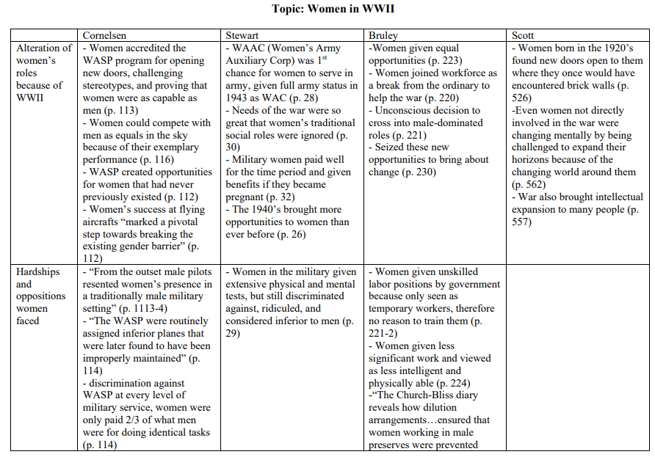
Example taken from Writing a Literature Review and Using a Synthesis Matrix by NC State University writing and Speaking Tutorial Service Tutors 2006
is licensed under a Creative Commons Attribution-NonCommercial-ShareAlike 3.0 Unported License.

Research Synthesis Matrix: Topic____________________________________________________
 | Author #1 | Author #2 | Author #3 | Author #4 | Author #5
Main Idea A
Main Idea B
Main Idea C
Main Idea D

