Assessing Student Learning in the Major

Mini-Resource Manual

Purpose:
Rather than share copies of workshop power-point slides, this Mini-Resource Manual has been prepared for workshop participants as a potentially more useful way to identify the assessment resources I’ve found particularly helpful in advancing assessment activities. The focus is on the assessment of student learning in the academic major but the perceptions I share, the suggestions I offer, and the resources I identify go beyond the assessment of what students learn as a result of completing an academic degree program.
The manual is organized around “ten important steps in the development of an academic department assessment plan.” These ten steps were cited (in some form or fashion) in several “Department Assessment Manuals” that will be identified. After identifying each step, I’d like to share my perceptions of why that step is important, what related resources I have found valuable, and occasionally share an example or describe a related technique or approach I’ve found effective.
Contents: Page
Step #1: Identify someone in the department to lead the process 2
Step #2: Collect and share assessment resource materials 5
Step #3: Agree on a department mission statement 8
Step #4: Identify student learning outcomes for each educational program 10

Step #5: Identify curriculum activities and experiences related to each 20
student learning outcome

Step #6: Identify direct & indirect assessment measures to monitor 23
attainment of each student learning outcome

Step #7: Develop a coordinated plan to collect data 28

Step #8: Summarize, analyze, interpret and share results 30

Step #9: Use findings to prompt improvement initiatives 32

Step #10: Develop & implement a plan to monitor the impact of improvements 34

Step #1 Identify someone in the department to lead the process

Importance:
Most assessment experts recommend there be broad-based faculty participation in the development and implementation of outcomes assessment activities but it is also important that someone be identified to assume responsibility for leading the assessment efforts within the department. Unless it is an assigned duty, the assessment efforts are often either fragmented or invariably left by the wayside as energies are devoted to other important department activities.
Suggestions:
Sometimes the department chair assumes responsibility for developing and coordinating outcomes assessment activities within the department. There are generally two reasons for doing so: it is a formal part of his/her departmental duties assigned by the dean or provost, or he/she would prefer to assume the lead role. I would suggest that if possible it not be the chair who serves as the Department Assessment Coordinator. It has been my experience that the most effective candidate is a veteran associate professor with 10+ years experience who may likely be looking for a “service” activity to help enhance their credentials for promotion to professor. Most chairs and deans would prefer that assistant professors focus primarily on their teaching effectiveness and their scholarly and research productivity with less attention to the service component of their tenure and promotion policies.
The veteran associate professor is likely going to want either some reduction in teaching responsibilities or additional compensation to assume the role of Department Assessment Coordinator. Invariably, the faculty member who might have an interest in the assignment is a very valued teacher in the undergraduate or graduate program, and often his/her chair does not want to reduce the teaching assignment. Attentive to this likelihood, I have found it best to offer add-pay to the associate professor. It may be even more attractive to offer a summer stipend for this year-long activity when the faculty member is on a 10 month contract.
Most faculty willing to consider this role will also want to know what is expected in meeting this responsibility. I suggest the duties and responsibilities be clearly defined before the fact so that the faculty member is not thrust into a position of “discovering” what is expected (this Mini-Resource Manual could be useful as an “overview” tool to share with prospective candidates). It is also important to preserve the authority of the chair who is ultimately responsible for the administration and operation of the department.
Example of a Position Description
Faculty who might be interested in serving as their Department Assessment coordinator will likely want answers to the following two questions: What do I have to do and when do I have to have it done? Recently, at the University of Alabama, we created the following two-page handout outlining the 2010-2011 “whats” and the “whens” for out Department Assessment Coordinators:

Outline of Position Description
Department Assessment Coordinator
When During
Responsibility Description Academic Year

1. Prepare Departmental Collaborate with the Department Chair and faculty within Aug 15 – Sep 15
Assessment Plan the department in preparing a Department Assessment Plan
For the upcoming academic year.
(There is no expectation that the department mission statement
and/or the existing undergraduate and graduate program student
learning outcome statements would necessarily change every year,
but if there are modifications, this would be the time to incorporate
them)

The Department Assessment Plan should be consistent with
the Department Assessment Planning Guidelines prepared by
the University Assessment Council.

Assuming no changes in the mission statement or student
learning outcome statements, the Departmental Assessment
Plan would identify the assessment measures to be employed
during the fall and spring semesters to monitor progress in
accomplishing the program-level* student learning expectations.
(* = Note the emphasis on program-level student learning outcomes
in the Department Assessment Plan as distinct from course-level
student learning objectives and outcomes. It is not an assigned
responsibility of the Department Assessment Coordinator to drill down
to the course level to monitor the preparation of learning outcomes consistent with program expectations, but he/she may likely serve as a
resource to his/her colleagues to assist in developing course-level
outcomes statements consistent with and aligned to program level
expectations.

Submit Department Assessment Plan to the Department Chair Sep 1
who approves and subsequently sends it to the Dean.

2. Assume Lead Role in Assume lead role within the department in ensuring the Sep 01 – Dec 01
Coordinating the Execution planned fall semester assessment efforts are conducted.
of Fall Semester Assessment
Activities

3. Represent the Department on Represent the Department on College and/or Institution- Sep - May
College and/or Institution level committees that address assessment-related matters
Committees (i.e., SACS Reaffirmation Committees, Discipline-specific
accreditation committees, Program Review Committees, etc.)

When During
Responsibility Description Academic Year

4. Participate in / Attend Participate in and/or attend the annual inter-departmental Second Week in Oct
Annual Inter-departmental outcomes assessment knowledge sharing sponsored by the
Outcomes Assessment University Assessment Council / Office of Institutional
Knowledge Sharing Effectiveness (This will be a half-day event at which
departments will share assessment approaches and results
from the previous year

5. Prepare Summary of Fall Prepare summaries of fall semester assessment results.
Semester Assessment Share summaries with Department Chair and Department Dec - Jan
Results Faculty

6. Assume Lead Role in Assume lead role within the department in ensuring the Jan 05 – May 01
Coordinating the Execution planned spring semester assessment efforts are conducted
of Spring Semester
Assessment Activities

7. Attend / Participate in Attend / participate in the annual Active & Collaborative Feb
Annual Active & Collaborative Learning Conference
Learning Conference

8. Prepare Summary of Spring Prepare summaries of spring semester assessment results.
Semester Assessment Share summaries with Department Chair and Department May - June
Results Faculty

9. Lead discussion/interpretation Assume lead role / collaborate with Department Chair and Apr - June
of Fall & Spring Assessment faculty within department to interpret Fall and Spring semester
program-level assessment results and collectively determine if
improvement actions are needed / called for

10. Prepare Annual Department Prepare an annual department assessment report wherein the July
Assessment Report results of assessment activities are reported, what conclusions
were drawn from those results and what improvement actions
are planned for the forthcoming year.

Submit Department Annual Assessment Report to the
Department Chair who approves and sends it the College Dean

11. Update Information in Submit department level unit profile updates and degree program Aug 01- Aug 15
UAOPS unit profile updates to the Office of Institutional Research and
Assessment

Step #2 Collect and share assessment resource materials
Suggestions:
Virtually every institution of higher education now has identified someone at the institutional level to coordinate assessment and/or institutional effectiveness initiatives, usually on a full-time basis. At larger research-intensive universities, it is not uncommon for there to be a division-level and college-level assessment coordinators or directors that also assume lead roles in advancing discipline-specific assessment and/or accreditation efforts.
It is important for department-level assessment coordinators to continuously receive resource materials that will assist them in meeting their assigned duties, but it is often difficult for them to keep abreast of new publications and innovative websites because they’ve assumed their assessment role on a part-time or add-on basis. Perhaps it is easier for full-time assessment officers to stay abreast of new resources and to “knowledge-share.” One suggestion might be for the full-time assessment officers to set a goal to send every department assessment coordinator at least one new assessment-related print resource and one new assessment-related website resource every semester.

Useful Assessment Textbooks:
Walvoord, B Assessment clear and simple. San Francisco: Jossey –Bass, 2004.
Suskie, L. Assessing student learning: A common sense guide. Bolton, MA: Anker, 2004
Allen, M.J. Assessing academic programs in higher education. Bolton, MA: Anker, 2004.
Maki, P.L. Assessing for learning: Building a sustainable commitment across the institution. Sterling, VA: Stylus, 2004.
Barkley, E., Cross, P. and Major, C. Collaborative learning techniques: A handbook for college faculty. San Francisco: Jossey-Bass, 2005.
Stevens, D.D. and Levi, A. Introduction to Rubrics: An assessment to save grading time, convey effective feedback and promote student learning. Sterling, VA: Stylus, 2005.
Driscoll, A and Wood, S. Developing outcomes-based assessment of learner-centered education: A faculty introduction. Sterling, Va: Stylus, 2007.
Banta, T.W., Jones, E. and Black, K. Designing effective assessment: Principles and profiles of good practice. San Francisco: Jossey-Bass, 2009.
Barkley, E. Student engagement techniques: A handbook for college faculty. San Francisco: Jossey-Bass, 2010.

Department Assessment Manuals:
1. Program Assessment Handbook
University of Central Florida
Website: http://oeas.ucf.edu/doc/acad_assess_handbook.pdf

Table of Contents
Chapter 1: What is assessment and why should you assess?
Chapter 2: How should you plan for program assessment?
Chapter 3: How do you define program mission and goals?
Chapter 4: How do you define student learning outcomes?
Chapter 5: How do you select and develop assessment methods?
Chapter 6: How do you document and use the results to improve programs?

2. Assessment Workbook
Ball State University
Website: http://web.bsu.edu/IRAA/AA/WB/contents.htm

Table of Contents
Chapter 1 Designing a Department Assessment Plan
Chapter 2 Shaping Department Goals and Objectives for Assessment
Chapter 3 Choosing Assessment Tools
Chapter 4 Using Surveys
Chapter 5 Using Tests
Chapter 6 Using Performance-Based Measures
Chapter 7 Using Focus Groups
Chapter 8 Using Available Data and Other Assessment Techniques
Chapter 9 Reporting and Using Assessment Results
Appendix List of Ball State Academic Assessment and Institutional Research Surveys

3. Assessment Guidebook for Departments
Bridgewater State College
Website: http://www.bridgew.edu/AssessmentGuidebook/

Table of Contents
1. Introduction: Assessment Then and Now
2. Overview of the Assessment Process
3. Developing a Program Mission Statement
4. Establishing Learning Outcomes
5. Assessment Tools
6. Implementation
•Examples of Program Assessment Tools and Rubrics
• Glossary of Terms

Assessment websites:

1. Internet Resources for Higher Education Outcomes Assessment
Ephraim Schechter (former Assessment Director, NC State University)
Current: HigherEdAssessment.com (Self-employed)
Website: http://www2.acs.ncsu.edu/UPA/assmt/resource.htm

Index
• General resources--discussion groups, lists of links, archives of articles, etc.
• Assessment handbooks
•Assessment of specific skills or content
•Individual institutions' assessment-related pages
a b c d e f g h i j k l m n o p q r s t u v w x y z
•State boards & commissions
•Accrediting bodies
•Student assessment of courses & faculty

2. The Assessment CyberGuide of Learning Goals and Outcomes
(Second Edition, November 2009) American Psychological Association
Website: http://www.apa.org/ed/governance/bea/assessment-cyberguide-v2.pdf

Contents
• Understanding Assessment
• Designing Viable Assessment Plans
• Applying Strategies
•Sustaining an Assessment Culture

3. Assessment Instruments and Methods Available to Assess Student Learning in the Major
University of Wisconsin- Madison
Website: http://www.provost.wisc.edu/assessment/manual/manual2.html

4. Learning Outcomes Assessment Planning Guide
Cal Poly
Website: http://www.academicprograms.calpoly.edu/assessment/assessplanguide.htm#selecting

5. CMU Assessment Toolkit
Central Michigan University
Website: https://academicaffairs.cmich.edu/caa/assessment/resources/toolkit.shtml

Step #3 Agree on a Department Mission Statement
Importance:
Almost all of the regional and discipline-specific accrediting bodies emphasize the importance of creating a mission statement at the institutional level, the college level, the department level and even the educational program level. Planning and assessment activities are then evaluated with respect to the stated mission.
Suggestions:
The department assessment manuals referenced on Page 6 each include attention to the do’s and don’t of crafting a mission statement, but my favorite presentation was made by Susan Hatfield in her “Idea Paper #35” entitled Department Level Assessment: Promoting Continuous Improvement. The Idea Center is located at Kansas State University. It’s website address is:
www.theideacenter.org
There are a number of excellent “idea papers” presented on this site and I would encourage you to browse. Dr. Hatfield recently revised and re-titled her paper. It is now Idea Paper #45 entitled Assessing Your Program-Level Assessment Plan (image of Page 1 below)
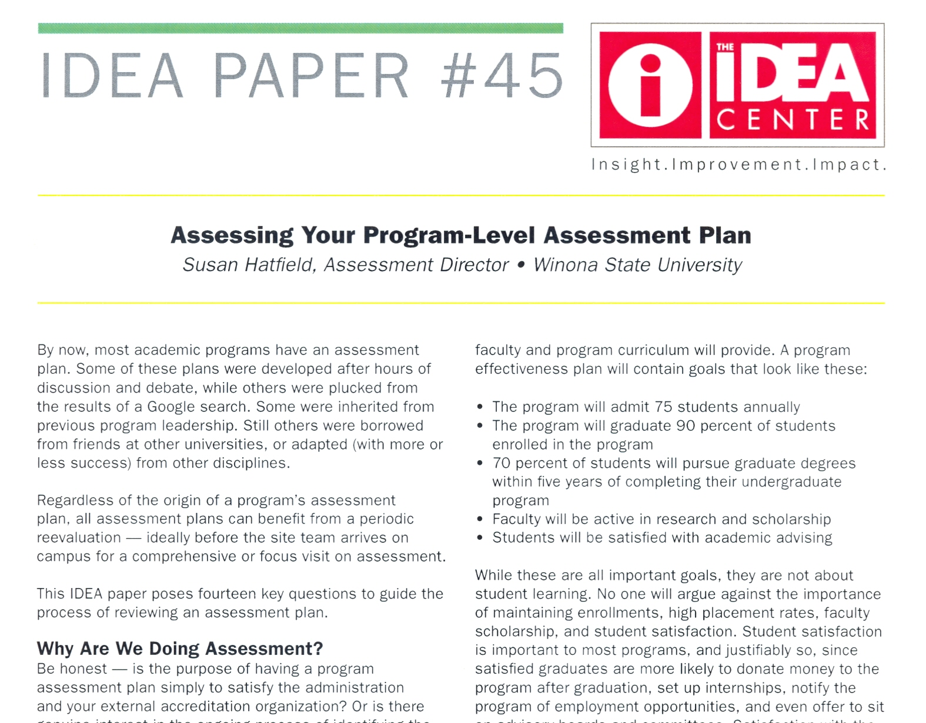

In her original idea paper, Dr. Hatfield said this about “Missions statements:
• to some “a mission is essentially a slogan”
•to others “ a mission is a statement of core values”
•to others “a mission should be a long statement”
•to others “a mission should be no longer than a sentence or two”
• to others “a mission should consist of a set of bullets”
Try within the department to reach “conceptual convergence”
` ➔ “who do you want to serve?”
➔ “in what ways”
➔ “ with what result”
She also cautioned the reader to avoid getting bogged-down in wordsmithing (my words, not hers) the expression of the mission statement or attempts to accommodate every function of the organizational unit.

Example:

Department of Communication Studies at Texas State University
Communication Studies examines the creation, transmission, and analysis of the messages we receive everyday. Communication Studies students investigate communication processes as they occur within and among individuals, groups, organizations, and societies. They explore interpersonal and nonverbal communication, rhetoric and criticism, argumentation and persuasion, and other aspects of communication.
Our Mission:
We teach communication principles, research methods and skills to Texas State students, produce and disseminate communication scholarship to a national and international constituency, and provide service to the department, the university, the community, and the profession.
We will:
- Facilitate learning about human communication by teaching all Texas State students (COMM 1310 Fundamentals of Human Communication) as well as providing high quality, comprehensive undergraduate and graduate communication programs to our majors and minors.
- Advance knowledge about human communication through the dissemination of high quality research in regionally, nationally, and internationally recognized publications.
- Provide professional service to enhance the quality and prestige of our programs, the university, and the discipline of communication.

Step #4 Identify goals and student learning outcomes for each educational program

Importance:
The expression of program goals and student learning outcomes for each degree program is often the most challenging step in the process of developing the department assessment plan and yet a most important step because they set the direction for the measurement and evaluation of student learning. The clear expression of student learning outcomes is also very valuable in helping department faculty think about their curriculum. They can determine in which of the required courses in the major each student learning outcome is addressed and where gaps may exist. Plans can be then be devised to introduce, reinforce or assess the outcomes in appropriate courses.
Suggestions:
In the resource materials identified in Step #2 you will find considerable attention devoted to the preparation of program goals and student learning outcome statements. You will see suggestions on how to go about devising goals for a program, on deciding what areas of learning the outcomes might address, the proper way to express the learning outcome statements, etc. Here is a sample of some of the thoughts emphasized:
In University of Central Florida’s Program Assessment Handbook, the authors outline some activities you can do that can help you articulate and shape program goals and student learning outcome statements. For example, they describe an approach based on the “ideal” student or graduate. They suggest that you conduct discussions and brainstorming sessions with the department faculty that focus on topics such as:
• Describe an “Ideal” student at various phases in your program, focusing on the abilities, knowledge, values and attitudes that you feel this student has either acquired or have been supported as a result of your program. Then ask:
- Cognitive Skills: What does the student know?
- Performance Skills: What can the student do?
- Affective Skills: What does the student care about?
• Describe how the students’ experiences in the program have contributed to their abilities, knowledge, values and attitudes.
• List the skills and achievements expected of graduates of the program

In Barbara Walford’s Assessment Clear and Simple, she emphasizes the importance of focusing on what the students will learn rather than what the instructor will teach when constructing student learning outcomes statements. For example, the form of the outcome statement might be…”Upon completion of the major, students will be able to…” rather than …the “the department will teach such-and-such a topic…”

In Mary J. Allen’s Assessing Academic Programs in Higher Education, she notes that program goals are often too general to guide assessment and planning, so faculty develop more specific learning outcomes to make the goals explicit. She stresses that learning outcomes operationalize program goals; they describe in concrete terms what program goals mean…not so specific that they are trivial, nor so general that they are vague.
One of the common threads that run through virtually all discussions of preparing student learning outcomes is the emphasis on one or more outcomes identifying what the student should know as a result of completing the major. Often times, this discipline-specific, content knowledge outcome statement is the most difficult to construct. When faculty in the program begin to discuss the body of content knowledge that all students should know upon graduation, turf wars can emerge. No faculty member is particularly comfortable with excluding content that falls within his/her area of expertise. “If what I know the most about is not important enough to be included in the required content of the major, maybe I’m not needed as a faculty member in this department,” said one of my (full-professor) colleagues in years past. This observation prompted me to develop an approach for “empirically deriving” what students should know rather than judgments being driven by emotion or seniority. I share the approach because it has worked for me, and maybe it would for you as well:
Six Step Process for Deciding (Empirically Deriving) What Majors Ought to Know
Step #1: Assemble the department faculty
No matter what the size of your faculty, divide them into either 3 or 4 groups. It’s best if you could meet in a conference room with 8 ft round tables so that each group of faculty are seated at one table. Let’s assume for purposes of this illustration that we have a department of 12 full-time faculty and we’ve seated them at four round tables in groups of 3.
Step #2: Give each table a different introductory textbook in the major
For purpose of this illustration, let’s assume this is a psychology department (but it could be Chemistry or Accounting, or Interior Design, etc.). On some campuses, all sections of the Introductory Psychology course use the same textbook while on other campuses, there might be 3 or 4 different texts being used across all sections of the introductory course. What you want to do in this step is to give each table a different textbook. For maximizing the probability this approach will work, I recommend you select introductory textbooks that are in at least their third edition. This will pretty much ensure that it is a representative text addressing the fundamentals of your discipline.
Step #3: Ask each group to examine the Table of Contents in their textbook and identify ten “sub- fields” of the [psychology] discipline derived from the chapter titles
In some textbooks there may be 20+ chapters while in others there may only be 12-15 chapters. Give the group about 15 minutes to work on this task. Emphasize that the goal of this task is to identify the “best 10” “subfields” of psychology that together will encompass the overall content of the discipline of psychology. (In effect, this approach assumes that the disciplinary content is captured in introductory

textbooks; this may be an erroneous assumption, but play along nonetheless). Here is a slide that illustrates the Table of Contents from two Psychology textbooks:
Textbook #1 Textbook #2
Table of Contents Table of Contents

Chapter 1 Introduction to Psychology Chapter 1 Introductory to Psychology
Chapter 2 Research in Psychology Chapter 2 Biology and Behavior
Chapter 3 Biological Aspects of Psychology Chapter 3 Sensation & Perception
Chapter 4 Sensation Chapter 4 States of Consciousness
Chapter 5 Perception Chapter 5 Learning
Chapter 6 Learning Chapter 6 Memory
Chapter 7 Memory Chapter 7 Cognition & Language
Chapter 8 Cognition & Language Chapter 8 Intelligence & Creativity
Chapter 9 Consciousness Chapter 9 Child Development
Chapter 10 Cognitive Abilities Chapter 10 Adolescence & Adulthood
Chapter 11 Motivation & Emotion Chapter 11 Motivation & Emotion
Chapter 12 Human Development Chapter 12 Human Sexuality & Gender
Chapter 13 Health, Stress and Coping Chapter 13 Personality Theory & Assessment
Chapter 14 Personality Chapter 14 Health & Stress
Chapter 15 Psychological Disorders Chapter 15 Psychological Disorders
Chapter 16 Treatment of Psychological Disorders Chapter 16 Therapies
Chapter 17 Social Cognition Chapter 17 Social Psychology
Chapter 18 Social Influences Appendix: Statistical Methods
Appendix: Statistics in Psychological Research
References

After the four groups appear to have their list of subfields, go to a flipchart or chalkboard and in round- robin fashion, ask each group to give you one of their sub-fields that has not already been mentioned previously by another group. Record the subfield on the flipchart.
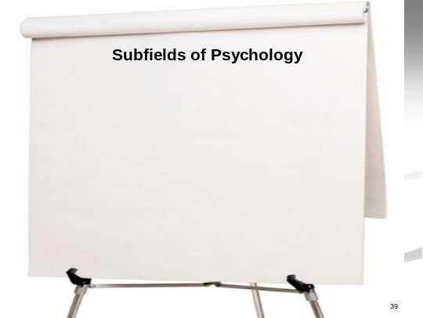

Each group will report 2 or 3 of their subfields. Once you have ten subfields, ask them if they would like to suggest any changes (e.g., replace one of the recorded subfields with another, combine two of the

subfields in order to add another subfield to the list, etc) To make any change on the list, three of the four tables must agree.
For purpose of illustration, let us assume that our four tables came up with the following list of ten Subfields of Psychology:
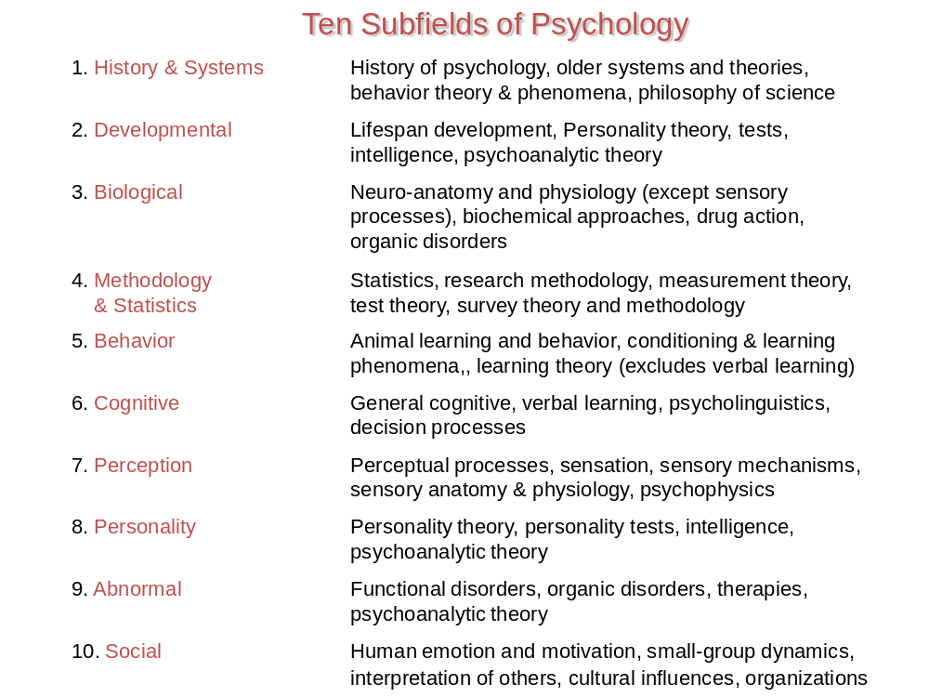

Step #4: Next pick one of the ten subfields and prepare a list of 25 key terms, concepts, principles, theories, etc. that are presented in the respective textbook chapter.
I generally begin this task by inviting the group to suggest a sub-field we might work on. For purposes of illustration, let’s assume the faculty chose the “Biology” subfield. I then ask all four tables to spend 10 minutes making a list of the important concepts, terms principles, theories, etc that are presented in the “Biology” chapter in their textbook. In most textbooks these days, the author gives emphasis in some way to important terms, principles, concepts. Sometimes the key terms are typed in bold. Sometimes they appear as a margin notes. Sometimes authors presents important points at the end of the chapter. It is not difficult to prepare a list of 25 key concepts.

Once it appears that each table has prepared their list, I then go to the flipchart and in round robin fashion, ask each table to suggest one important concept. I record that concept on the flip chart similar to what I have depicted below:

Subfield = Biological
Biological
Neuron
Axon
Dendrite
Synaptic transmission
Central Nervous System

Cortex

Cerebellum

It is not uncommon for the key terms to be at all levels of specificity and generality. Once we get to 25 key terms, I then open it up to all tables to make suggested changes. Again, usually some terms are dropped and replacements suggested. Many times faculty will say that 25 key terms are not enough to capture the breadth and depth of important knowledge within the chapter and want to increase the number from 25 to 50, or even 100.
Repeat this process for the other 9 subfields. I usually divide up the remaining subfields equally among the tables. In this case 2 subfields per table with one table having three subfields. Suprisingly, this can be done in less than 30 minutes.
Step #5: Create a rating form for each subfield and ask all faculty within the department to rate the importance of each key term, concept, principle, theory, etc. entitled:
At this point in the exercise, I usually confess that I stole this idea from Dr. Alan Boneau who wrote an article in 1990 in the American Psychologist entitled Psychology Literacy: A First Approximation. After Alan created his lists of terms for each subfield he created the following rating form:
Criteria for Rating Terms
Very Important (5) All psychology baccalaureates should be able to make knowledgeable statements about this term
Important (4) All psychology baccalaureates should, at a minimum, recognize this term
Somewhat But all psychology doctorates should be able to make knowledgeable specialized (3) statements about this term (and, of course, all above)
Specialized (2) ` But all psychology doctorates should, at a minimum, recognize this term
Overly specialized (1) This is too specialized for general knowledge even at the doctoral level

He then asked faculty to rate each of the key terms, assigning a “5”if the rater believed that all psychology baccalaureates should be able to make knowledgeable statements about the term, assign a “4” if baccalaureates should at least be able to recognize the term, etc.
In my use of Dr. Boneau’s work, I ask faculty to assign either a “4” or a “5” to each term. Each faculty member thus rates 250 key terms and concepts in terms of whether the term is one a psychology baccalaureate ought to be able to make knowledgeable statements about (5) or simply be able to recognize as a term within the discipline of psychology (4). Here is alphabetized list of terms (and a place for a rating) that were included in Dr. Boneau’s list of 100 terms drawn from the Biological subfield:
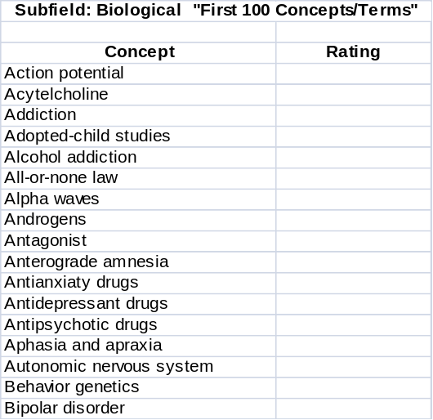

Here is a sample result from the rating process:
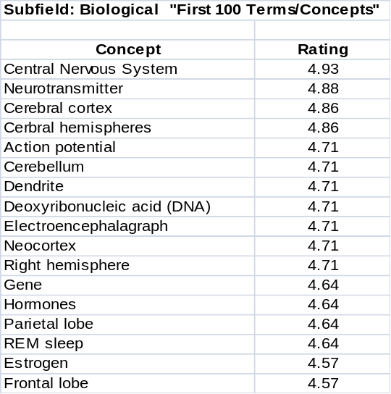

Here is another example of the ratings results, this time for the subfield Behavior (i.e., animal learning and behavior, conditioning and learning phenomena, learning theory)
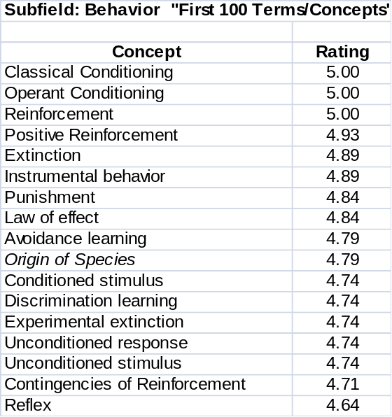

Notice there were three terms in Dr. Boneau’s list of 100 “Behavior” terms that had an average rating of 5.00. That means that every faculty rater believed these were terms that all baccalaureates should be able to make knowledgeable statements about.
Take a look at the number of terms in the Methodological and Statistics subfield below that received an average rating of”5”:
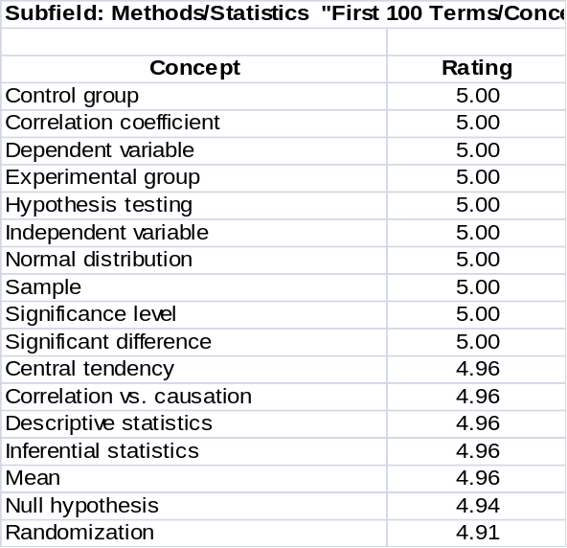

There appears to be more agreement among faculty regarding what baccalaureates ought to be able to make knowledgeable statements about in the subfield of statistics and methodology than in the other subfields. Can

you think of a reason why? Is this unique to Psychology?
Step #6: Identify the top 100 most important terms, concepts, principles, theories, etc. across all subfields.
After your faculty participants have rated the 25 key ten terms in each of the 10 subfields, create a new table that represents the (David Letterman) top ten key terms in each subfield. It might look something like this:
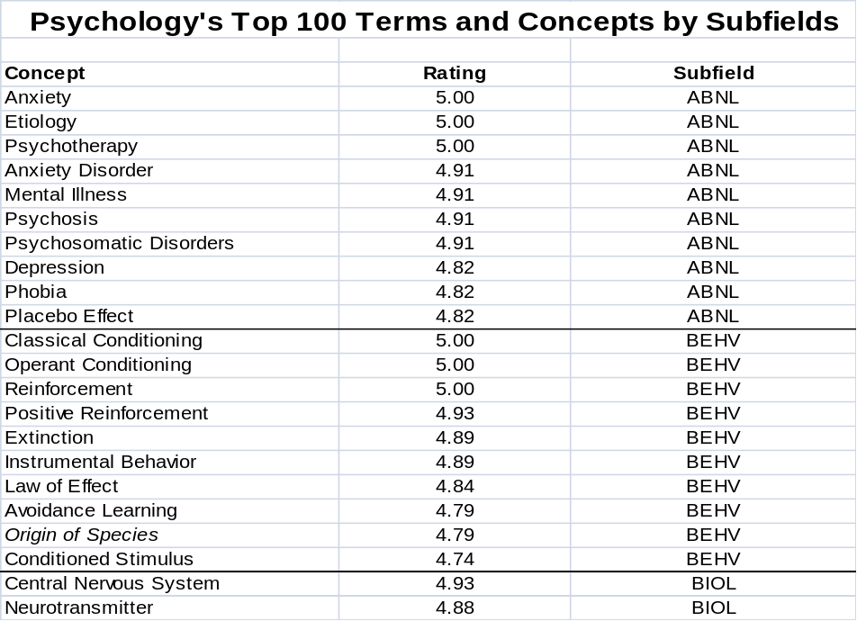

Or you might want to identify what your faculty believe to be the top 100 key terms regardless of subfields. If so, the results might look like this:
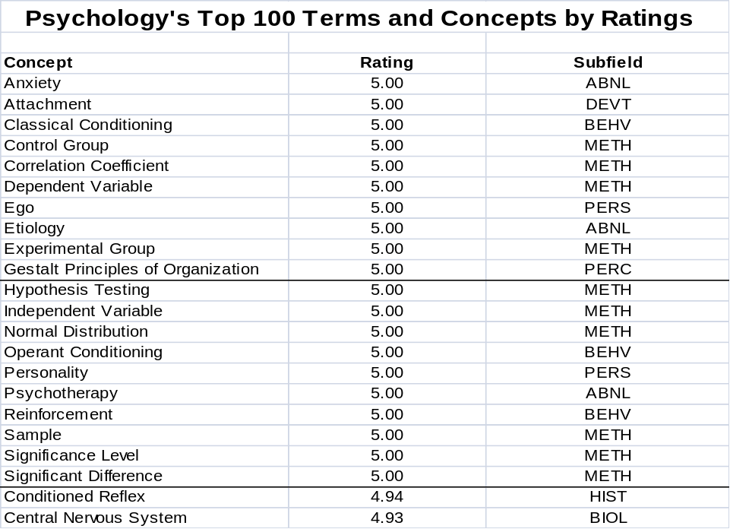

Let’s reflect on what we’ve attempted to do in this exercise. We set out to try to empirically derive what we want our students to know upon completing our major. This exercise was designed as an approach to accomplish that end. But most faculty, as Dr. Allen notes in her Assessing Academic Programs in Higher Education…”abhor the thought that students might memorize isolated facts and concepts without developing the ability to use that knowledge; but teaching, grading and assessment practices can promote the very surface learning that we want to avoid.”
So in order to promote deep learning, we will want to include program goals and student learning outcomes that go beyond foundation content knowledge and call upon our baccalaureates to apply, to analyze, to synthesize and to evaluate drawing on the content knowledge attained in our sequence of required courses in the major. The key terms and concepts derived in a manner similar to the above might be conceived of as the building blocks for higher order (Bloom’s) cognitive activities. But even with that as your emphasis, you might want to design some preTest – postTest assessment measures to document mastery of these important key concepts and principles as part of your overall program assessment plan.

Examples of Student Learning Outcomes
Several websites often referenced where one may find examples of student learning outcomes are:
University of Colorado at Boulder
Website: http://www.colorado.edu/pba/outcomes/

George Mason University
Website: https://assessment.gmu.edu/ProgramGoals/index.html

Bridgewater State College
Website: http://www.bridgew.edu/AssessmentGuidebook/outcomes.cfm

Several years ago the State of Florida mandated what were called Academic Learning Compacts. By legislative act, for all baccalaureate programs, universities were required to develop Academic Learning Compacts that
a. identify, at a minimum, the expected core student learning outcomes for program graduates in the areas of
i) content/discipline knowledge and skills;
ii) communication skills;
iii) critical thinking skills; and
b. identify corresponding assessments used to determine how well student learning matches those articulated expectations.

The universities in Florida were required to post their academic learning compacts on their institutional websites. Here are some websites where academic compacts are posted that may be a useful resource for

examining samples of outcome statements across a wide variety of academic disciplines:

Florida Atlantic University: http://iea.fau.edu/pusateri/assess/ALC.htm
Florida Gulf Coast University: http://www.fgcu.edu/OCI/alc.html
Florida State University: http://learningforlife.fsu.edu/smalcs/learningCompacts.cfm
New College of Florida: http://www.ncf.edu/Provost/fpdb/ALC_questionnaire.asp
University of Central Florida: http://oeas.ucf.edu/alc/academic_learning_compacts.htm
University of Florida: http://www.aa.ufl.edu/aa/alc/
University of North Florida: http://www.unf.edu/acadaffairs/IE/alc/index.htm
University of South Florida: http://www.ie.usf.edu/ALC/

Step #5 Identify curriculum activities and experiences aligned to each student learning outcome.

Importance:
It is important that the curriculum experiences be aligned with student learning outcomes to ensure that what students do in their courses will enable them to meet faculty expectations expressed in the stated learning outcomes. Analyzing the alignment of the curriculum experiences with learning outcomes allows for the identification of gaps or disconnects which can then lead to curriculum enhancements to improve student learning opportunities.
Suggestions:
The best way to analyze the alignment between the curriculum activities and learning outcomes is by organizing the data into a curriculum map. A curriculum map consists of a table with two axes, one pertaining to program learning outcomes, the other to courses in the major. To prepare the program curriculum map,
-List your program course numbers across the top of the table
-List your Student learning outcome on the vertical axis of the table
-Review each course to determine what educational activities and assignments helps students to attain a specific outcome
-Identify to what extent the course addresses each outcome

Here’s a sample template for a Curriculum Map:
 | Course #1 | Course #2 | Course #3 | Course #4 | Course #5 | Course #6 | Course #7
Learning Outcome 1 |  | ü | ü
Learning Outcome 2 | ü
Learning Outcome 3 | ü |  |  | ü |  |  | ü
Learning Outcome 4 |  |  |  |  | ü | ü
Learning Outcome 5 |  |  | ü | ü |  |  | ü

There are numerous scales one might employ to express the extent to which a given student learning outcome may be addressed. Here is an example of a threefold scale where
I=Introduced,
P=Practiced
D= Demonstrated
 | Course #1 | Course #2 | Course #3 | Course #4 | Course #5 | Course #6 | Course #7
Learning Outcome 1 | I |  | P |  | P | D
Learning Outcome 2 |  |  | I | D |  | P
Learning Outcome 3 |  | I |  | D |  |  | P
Learning Outcome 4 |  | I | P | P |  |  | P
Learning Outcome 5 | I | P |  |  | P |  | D

Here’s another scale that expresses how much emphasis is given, if any, to a particular learning outcome where L = low emphasis on outcome
M= Moderate emphasis on outcome
H= High emphasis on outcome
 | Course #1 | Course #2 | Course #3 | Course #4 | Course #5 | Course #6 | Course #7
Learning Outcome 1 | L | L | M | H | H | H | H
Learning Outcome 2 |  |  | L |  | L | M | M
Learning Outcome 3 | L | L | L |  | M | L | M
Learning Outcome 4 |  | H | L | M |  | L | L
Learning Outcome 5 | H | H | H | H | P | H | L

Resources:

Bridgewater State College
Assessment Guidebook
Website: http://www.bridgew.edu/AssessmentGuidebook/chapter4.cfm

Westminster College
Assessment Primer: Curriculum Mapping
Website: http://www.westminster.edu/acad/oaac/pdf/mapping.pdf

Podcast: Dr. Ron Carter, Provost
Loma Linda University
“Developing Curriculum Maps”
Website: http://wascsenior.ning.com/video/developing-curriculum-maps

Step #6: Identify appropriate assessment methods and measures
Importance:
Since meeting accreditation expectations is such a significant consideration in preparing plans for assessing student learning in the major it is particularly important to carefully examine the specific expectations of those bodies regarding assessment measures. For example, almost all agencies expect one to employ multiple measures in monitoring achievement of student learning outcome s. More recently both the regional and discipline-specific accreditors have emphasized that the exclusive use of indirect assessment measures are insufficient to adequately demonstrate the achievement of student learning outcomes. Employing direct assessment measures for each student learning outcome has come to be a must.
Just as it was important to align curriculum experiences with the identified program-level student learning outcomes, it is also important that the choice of assessment measures are carefully aligned to the curriculum activities and student learning outcomes that have been identified in the major. If such alignment doesn’t exist, or if the alignment is weak, it is difficult to draw sound inferences regarding the meaningfulness of assessment results and the subsequent potential to derive areas for improvement initiatives.
Suggestions:
The resources identified in Step #2 include extensive attention to assessment measures. As a starting point in examining the variety of assessment approaches, I would suggest these two resources in particular:
Assessment Instruments and Methods Available to Assess Student Learning in the Major
University of Wisconsin – Madison
Website: http://www.provost.wisc.edu/assessment/manual/manual2.html

The Assessment CyberGuide of Learning Goals and Outcomes
(Second Edition, November 2009) American Psychological Association
Particularly, Evaluating Assessment Strategies, Page 14-28.
Website: http://www.apa.org/ed/governance/bea/assessment-cyberguide-v2.pdf

Both these reference resources are valuable because they not only indentify a wide variety of assessment approaches, but also identify their strengths and limitations and advantages and disadvantages.

Preferred Direct Assessment: Rubrics

As emphasized in Step #5 in preparing student learning outcomes in the major, it is uniformly recommended that the focus be on what students should know and what they should be able to do as a result of completing the major. In addition to discipline content knowledge and skills, most assessment plans include attention to

communication skills, higher order thinking skills (critical thinking, problem solving, etc) and affective skills (attitudes and values). While there are numerous direct assessment approaches that cans serve as empirically sound measures of these additional learning outcomes, the direct assessment approach that I most frequently advocate is the use of a rubric.

Here are two resources I find most helpful to those interested in developing a rubric in their courses or co-curricular experiences:

Textbook:
Stevens, D.D. and Levi, A. Introduction to Rubrics: An assessment to save grading time, convey effective feedback and promote student learning. Sterling, VA: Stylus, 2005.
This is a useful and simple-to-follow “how to” text on best practices in developing a rubric. (We like it so much at the University of Alabama we purchased 500+ copies and distributed the copies to interested faculty and staff. We also invited the authors to campus to conduct a day- long workshop attended by 150+ faculty.
Website:
Susan Hatfield
Winona State University
http://www.winona.edu/air/rubrics.htm

This is an excellent resource that enables one to examine examples of rubrics from assessing skills in writing, critical thinking, and analytical reasoning to student collaboration, teamwork and class participation.

Bob Smallwood
University of Alabama
http://assessment.ua.edu/Rubrics/UA_Faculty_Rubrics.html

This is a section of the assessment website where we posted rubrics used by UA faculty during the Spring, 2009 semester as part of a mini-grant program where faculty introduced rubrics as an assessment tool in one of their courses.

Preferred Indirect Assessment: NSSE

Over the past ten years I have found the NSSE to be a very worthwhile assessment instrument. Results from its administration have prompted institutional initiatives to strengthen student-faculty relations, to redesign course experiences to heighten active student involvement in their learning, to broaden institutional interest in providing educational enrichment experiences for students, and to strengthen institutional support service to maximize student success.

On the NSSE website (http://nsse.iub.edu/ ) , there are many very useful resources to help inform institutional effectiveness efforts. You might pay particular attention to the NSSE Institute site (see http://nsse.iub.edu/institute/ ) that provides information and links to using NSSE data, to reports and updates about NSSE research projects, and to the services offered by the Institute.

I have had the good fortune or working closely with NSSE staff over the past ten years with a particular interest in involving faculty in advancing student engagement initiatives. Invariably,as I did so, faculty would ask me to identify published research articles related to the various educational practices assessed by the NSSE. I recently finished and posted a NSSE Bibliography I would like to now share:

NSSE Benchmark Bibliography

The following is a resource identifying approximately 400 research articles related to items on the NSSE organized around the five NSSE benchmarks: http://assessment.ua.edu/Smallwood/benchmarks.htm

Here is the NSSE Benchmark Bibliography main page:


If you click on one of the Benchmark pages, the respective items for that benchmark appears. Here is the “Active & collaborative Learning Benchmark page:
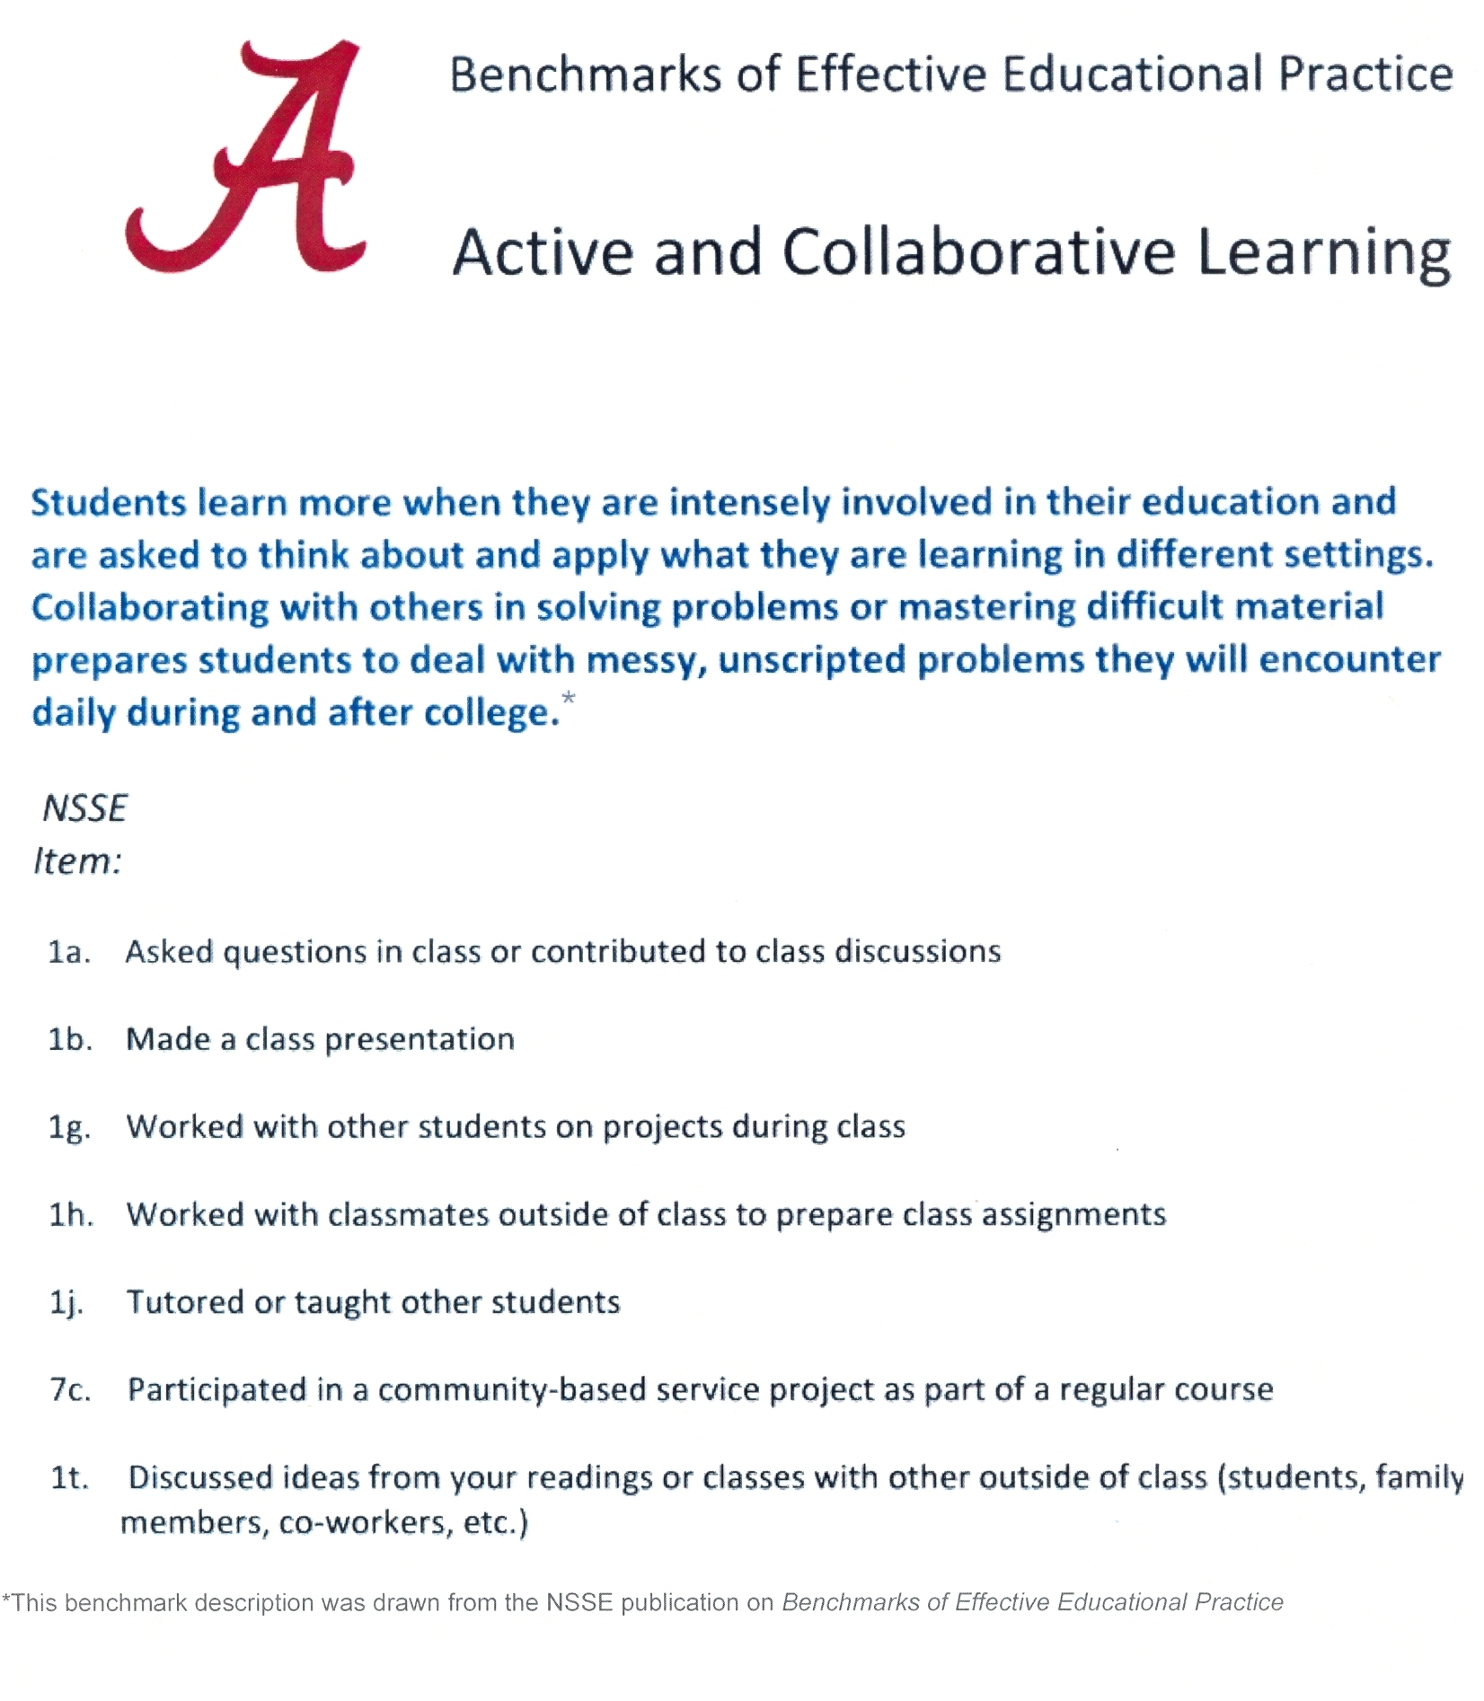

If you then click on a particular NSSE item within that benchmark, a list of relevant bibliographic citations are shown, as depicted below:

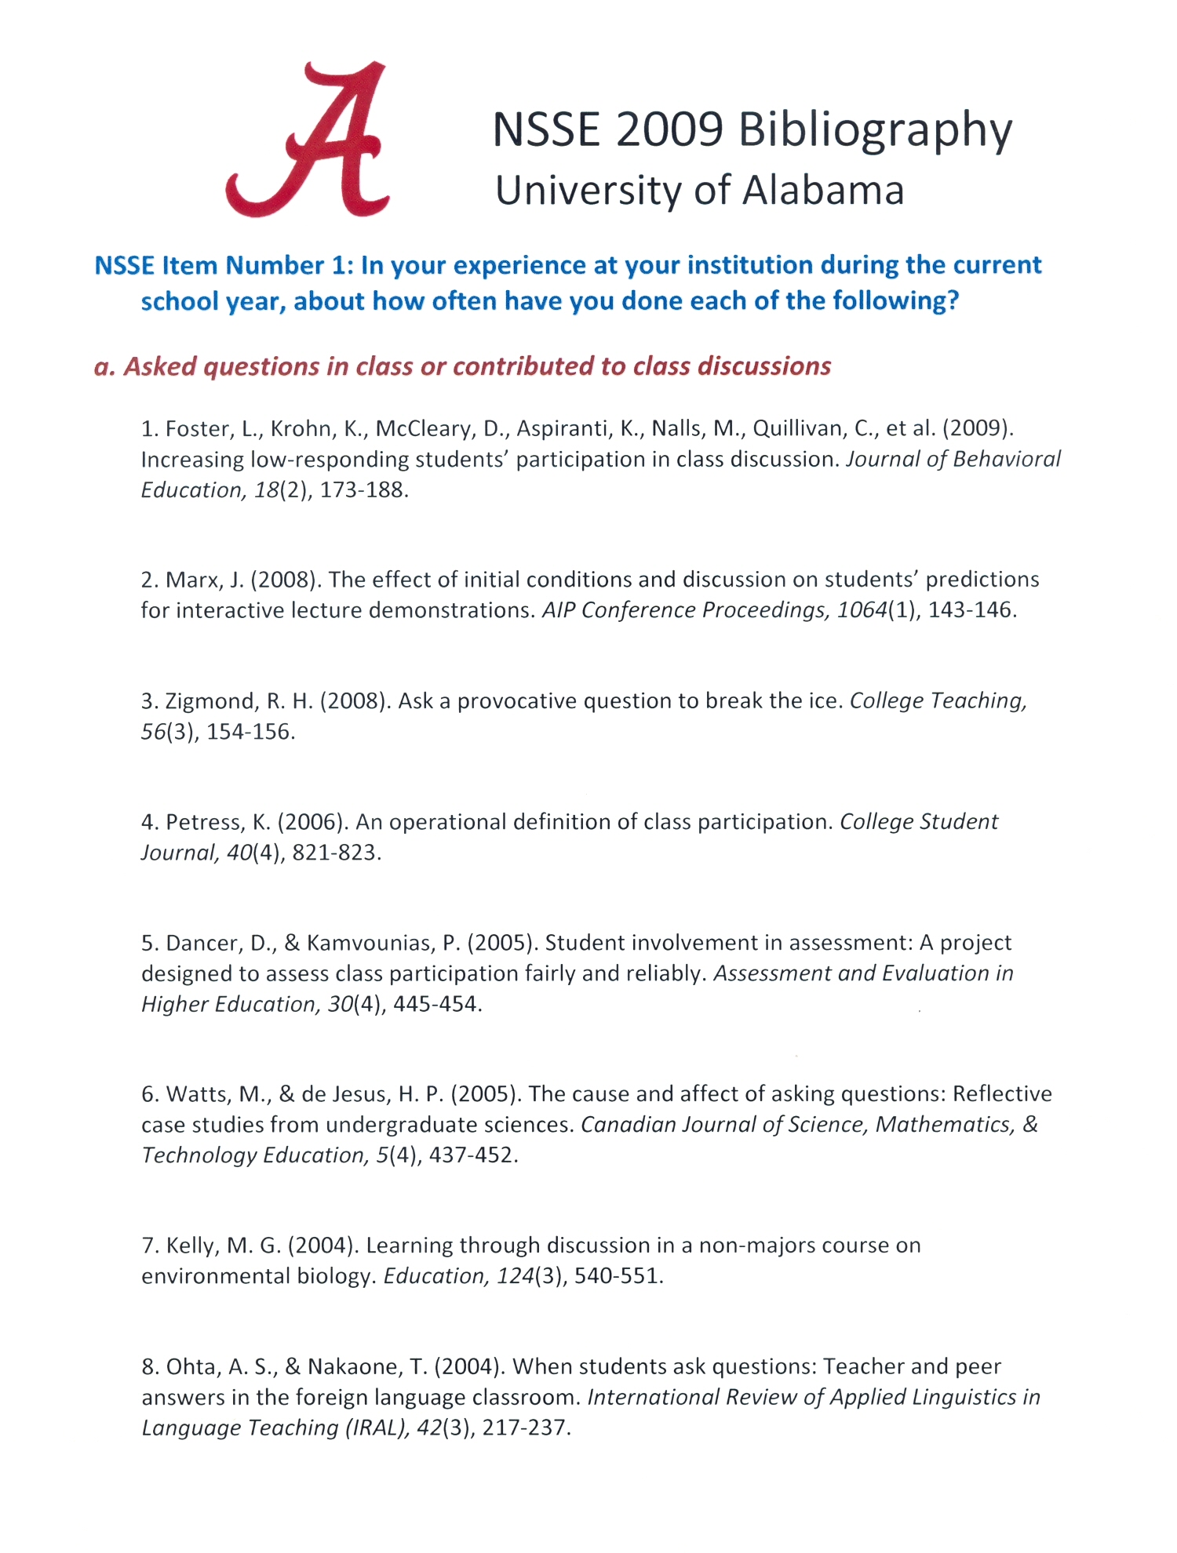

CLASSE:

Over the past three years I have also been working on the development of a classroom-level measure of student engagement called the CLASSE (Classroom Survey of Student Engagement). My research partner (Dr. Judy Ouimet) and I received permission from NSSE officials to pilot test an adaptation of NSSE that calls for students to report their level of engagement in a single course. In addition, similar to some of the items that appear on the FSSE (Faculty Survey of Student Engagement) the faculty instructor is asked how important each educational practice is in the class for students to be successful. The results from the administration of CLASSEStudent and CLASSEFaculty are then combined and analyzed. The result is a report that identifies what particular educational practices the faculty member particularly values that are not occurring as frequently as others. This diagnosis helps to inform initiatives for instructional improvement.

More information about participating the 2009-2010 CLASSE Pilot Study can be found here:
http://nsse.iub.edu/html/classe.cfm

Step #7: Develop an action plan to collect data.
Importance:
There is wisdom in beginning the academic year with an assessment plan and ending the year with an analysis and interpretation of findings. Without a well-defined intervening implementation plan for the collection of data, the overall success of the assessment plan will likely be compromised.
Suggestions:
An often-cited assessment cardinal rule is…don’t try to assess all the program level student learning outcomes at once. One of the guidelines advocated by the UA Assessment Council is for each student learning outcome to be assessed, results analyzed and potential improvements devised and executed within a two year time span. The ultimate goal is to complete two assessment cycles for each student learning outcome over a five year period.
Just as a curriculum map was an effective tool for representing the alignment between curriculum activities and specific student learning outcomes, a similar strategy can be implemented to organize the execution of assessment efforts. An “assessment matrix” can be created that lists the student learning outcomes in the first column (the “what”) and then
a. who will take the lead role in conducting the assessment
b. where in the curriculum the student learning outcome is addressed,
c. when the assessment will be collected
d. what direct assessment measure(s) will be employed to assess achievement of the outcome
e. what indirect assessment measure(s) will be employed

The Matrix might look something like this:
Assessment Implementation Plan
What | Who | Where | When | How (Direct) | How (Indirect)
Student Learning Outcome #1 | Dr. Harriett _________ | Course X | Fall, 8th week | Course Embedded Assessment
 | Dr. Thomas _________ | Course Y | Fall, 15th week | Rubric
 | Department Assessment Coordinator |  | Fall, 13th-14th Week |  | One item on Graduating Senior Survey
 | Dr. Sally _________ | Course Z | Spring, 13th Week | Rubric | Two items on End-of-Course Student Evaluation

Sometimes the assessment matrix is expanded by adding a column to present a brief summary of assessment findings, another column for inferences, interpretations, and conclusions and a third additional column to identify an improvement or constructive change derived from the interpretation of the assessment findings. The impact of the constructive change or improvement initiative becomes an outcome to be assessed during the next assessment cycle.

Step #8: Summarize, analyze, interpret and share the assessment results

It is not uncommon for most of the assessment activities in the major to occur during the second half of each semester. That translates into November and April being critical months for the collection of assessment data within the major.
This concentrated data collection period poses a difficulty for the assessment planning process. It’s often too late in the fall semester (end of November) for data to be summarized, analyzed and interpreted in time for potential improvements to be identified and acted upon by the beginning of the spring semester. So it is often January or February before faculty can actually examine and discuss fall assessment results.
A challenge of a slightly different nature occurs after the spring term. So many faculty are not available in May and June to examine and discuss spring semester findings so it is difficult for the spring data to influence the preparation (in August) of the assessment plan for the following academic year. Many departments struggle with these timeline challenges. The most common resolution to the challenge is to plan to discuss assessment results each year during the months of September and February and draw from those discussion in preparing the annual assessment plan in August.
Suggestions:
1. For each assessment conducted, I recommend preparing two assessment reports:
a) an executive summary of 100-150 words that reports the main results and the meaningfulness of the findings.
b) a more detailed, multi-page summary with statistical analyses and empirically sound conclusions. Whenever possible, I try to disaggregate results to a smaller unit of analysis to facilitate more detailed interpretations of the findings. My rule of thumb is that disaggregated analyses must have a sample size of at least `15 respondents.

2. Whenever possible, I try to form a small focus group of majors in the department to help me interpret the meaningfulness of the results of a collection of assessments. Scheduling a luncheon with free pizza always seems to work. Sharing student interpretations and meaningfulness of findings is a good way to kick-off the faculty discussions of the same data in September and February.

3. In addition to drawing conclusions from the assessment results, I like to try to generate and share at least two meaningful research questions prompted by the findings, research questions that could serve as a senior thesis project or an independent study for a student. Frequently, a faculty member will take on the research question and mentor a student assistant in the initiative.

4. Once a year, usually in October, It is a good practice to send a summary of assessment findings to all currently enrolled majors in the discipline. Students need to see that we learn from the results of our assessment efforts and strive to consequently improve. Response rates to indirect assessment efforts are positively impacted as a result.

5. I suggest you strive to spend as much time sharing assessment results as you do collecting the assessment data. It is a difficult goal to attain.

Step #9: Use results to prompt improvement initiatives.
Importance:
Almost all the regional and disciplinary accrediting bodies are requiring that improvements be advanced as a result of what is learned from the assessment of student learning outcomes.
Suggestions:
Sometimes it is difficult to determine when an improvement initiative is warranted following the assessment process. The authors of the University of Central Florida’s Program Assessment Handbook (see http://oeas.ucf.edu/doc/acad_assess_handbook.pdf ) draw attention to three categories of changes that are often made as a result of conducting assessments:
Categories of Constructive Changes (Improvements)
- 1. Changes to the Assessment Plan
- a. revision of intended student learning outcome statement(s)
- b. revision of measurement approaches
- c. collection of and analysis of additional data and information
- d. changes of data collection methods

- 2. Changes to the Curriculum
a. changes in pedagogical practices
b. revision or enforcement of prerequisites
c. revision of course sequence
d. addition of courses
e. deletion of courses

- 3. Changes to Academic Processes
a. modification of the schedule of course offerings
- b. improvements of technology
- c. changes in personnel
- d. initiate additional faculty development experiences
- e. revision of advising standards or processes
- f. revision of admission criteria

As a general rule, when assessment results fail to meet expectations, it’s probably wise to first consider methodological improvements (i.e, replicate with a new, larger sample, collect comparable information with a different assessment approach, etc.) to be sure the inferences and conclusions drawn from the results are empirically sound.
It is also important to be conscious of the fact that faculty routinely make improvements in the conduct of their course, not prompted necessarily by an assessment finding but by their interest in exploring new, more effective approaches to instruction. Instructional improvements do not necessarily need to be driven by assessment results, and less than favorable assessment results do not necessarily mean that instructional improvements need to be advanced.

At the University of Alabama, we are planning an (October)annual inter-departmental, outcomes-assessment, knowledge-sharing day (1/2 day) at which faculty and Department Assessment Coordinators will share assessment approaches and results from the previous year. We anticipate these knowledge-sharing activities are as likely to prompt constructive changes in teaching and learning as specific assessment results within the major.

Step #10: Develop and Implement a plan to monitor the impact of improvements

If the assessment results from monitoring the attainment of a student learning outcome leads to advancing an improvement initiative, then a plan to assess the impact of that improvement initiative needs to be part of the assessment plan for the coming year.
Is there some minimum number of improvement actions that accreditors require in order to meet their expectations? I think the answer is no. Yet accreditors often embrace continuous improvement as one of their core values so there is an expectation that it is central to the assessment planning process. At the University of Alabama, we expect there to be at least one improvement initiative advanced per student learning outcome within each degree program during our two year assessment cycle.

`

